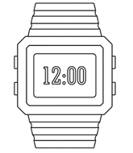

**PO3_DGW_Digital watch**

**(LCD)**

Table 1 Status Table

|  |  |  |  |  |
| --- | --- | --- | --- | --- |
| **Document Name** | **Author** | **Version** | **Date** | **Status** |
| LCD_CDD | Basma Abdelhakim | 1.0 | 4/3/2020 | Draft |

**DOCUMENT HISTORY**

Table 2 Document History

|  |  |  |  |  |
| --- | --- | --- | --- | --- |
| **Version** | **Description of Change** | **Author** | **Date** | **Document Status** |
| 1 | Initial creation of LCD_CDD Document | Basma Abdelhakim | 4/3/2020 | Draft |

Table 3 Reference Table

|  |  |  |
| --- | --- | --- |
| Reference Input Documents | Version | Status |
| SRS | 1.7 | Proposed |
| GDD | 1.2 | Proposed |

Table of Contents

**1.LCD software context diagram** 3

2.Component ʹs application programming interfaces (APIs) 4

List of Tables

Table 1 Status Table 2

Table 2 Document History 2

Table 3 Reference Table 2

# **1.LCD software context diagram**

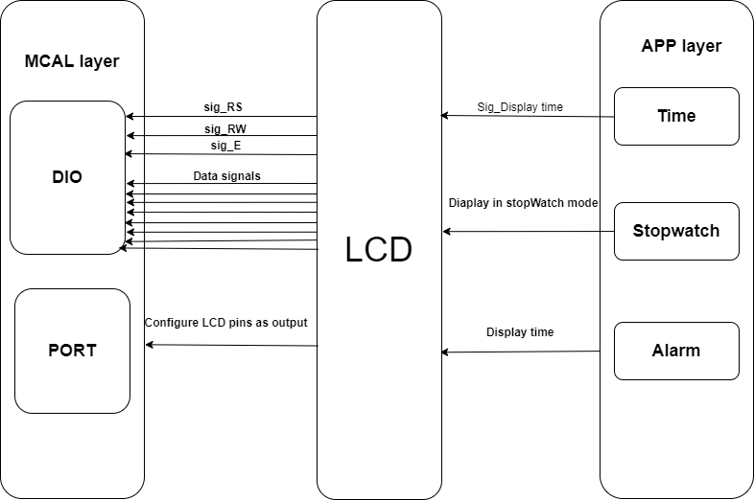

Figure 1. LCD context diagram.

# **2.Component ʹs application programming interfaces (APIs)**

|  |  |  |  |  |  |  |
| --- | --- | --- | --- | --- | --- | --- |
| **Req_ID** | | Req_PO3_DGW_LCD_CDD_01_V01. | | | | |
| **Covers** | | Req_PO3_DGW_GDD_10_V01.0. | | | | |
| **Author** | Basma Abdelhakim | **Date** | | 4/3/2020 | | |
| **API_Name** | CLCD_voidInitialize | **Scope** | | public | | |
| **Description** | | This function is used to initialize LCD according to datasheet | | | | |
| **Inputs** | | **Type** | **Name** | | **Description** | **Range** |
| void | NA | | NA | NA |
| **Outputs** | | void | NA | | NA | NA |
| **Algorithm** | |  | | | | |

|  |  |  |  |  |  |  |  |
| --- | --- | --- | --- | --- | --- | --- | --- |
| **Req_ID** | | Req_PO3_DGW_LCD_CDD_02_V01. | | | | | |
| **Covers** | | Req_PO3_DGW_GDD_11_V01.0 | | | | | |
| **Author** | Basma Abdelhakim | **Date** | | 4/3/2020 | | | |
| **API_Name** | CLCD_voidWriteCmd | **Scope** | | | public | | |
| **Description** | | This function is used to write command on LCD | | | | | |
| **Inputs** | | **Type** | **Name** | | | **Description** | **Range** |
| U8 | Copy_u8Data | | | Data | 0 to 255 |
| **Outputs** | | void | NA | | | NA | NA |
| **Configuration parameters** | | CLCD_u8_RS_PORT, CLCD_u8_RS_PIN  CLCD_u8_RW_PORT, CLCD_u8_RW_PIN  CLCD_u8_E_PORT, CLCD_u8_E_PIN | | | | | |
| **Algorithm** | |  | | | | | |

|  |  |  |  |  |  |  |
| --- | --- | --- | --- | --- | --- | --- |
| **Req_ID** | | Req_PO3_DGW_LCD_CDD_03_V01. | | | | |
| **Covers** | | Req_PO3_DGW_GDD_12_V01.0 | | | | |
| **Author** | Basma Abdelhakim | **Date** | | 4/3/2020 | | |
| **API_Name** | CLCD_voidWriteData | **Scope** | | public | | |
| **Description** | | This function is used to write data on LCD | | | | |
| **Inputs** | | **Type** | **Name** | | **Description** | **Range** |
| U8 | Copy_u8Data | | Data | 0 to 255 |
| **Outputs** | | void | NA | | NA | NA |
| **Configuration parameters** | | CLCD_u8_RS_PORT, CLCD_u8_RS_PIN  CLCD_u8_RW_PORT, CLCD_u8_RW_PIN  CLCD_u8_E_PORT, CLCD_u8_E_PIN | | | | |
| **Algorithm** | |  | | | | |

|  |  |  |  |  |  |  |  |
| --- | --- | --- | --- | --- | --- | --- | --- |
| **Req_ID** | | | Req_PO3_DGW_LCD_CDD_04_V01. | | | | |
| **Covers** | | | Req_PO3_DGW_GDD_12_V01.0 | | | | |
| **Author** | Basma Abdelhakim | | **Date** | | 4/3/2020 | | |
| **API_Name** | | CLCD_voidSetDataPort | **Scope** | | Private | | |
| **Description** | | | This function is used to set data port | | | | |
| **Inputs** | | | **Type** | **Name** | | **Description** | **Range** |
| U8 | Copy_u8Data | | Data | 0 to 255 |
| **Outputs** | | | void | NA | | NA | NA |
| **Configuration parameters** | | | CLCD_u8_DATA_PORT  CLCD_u8_D0, CLCD_u8_D1, CLCD_u8_D2, CLCD_u8_D3, CLCD_u8_D4, CLCD_u8_D5, CLCD_u8_D6, CLCD_u8_D7 | | | | |
| **Algorithm** | | |  | | | | |

|  |  |  |  |  |  |  |
| --- | --- | --- | --- | --- | --- | --- |
| **Req_ID** | | | Req_PO3_DGW_LCD_CDD_05_V01. | | | |
| **Covers** | | | Req_PO3_DGW_GDD_13_V01.0 | | | |
| **Author** | Basma Abdelhakim | | **Date** | 4/3/2020 | | |
| **API_Name** | CLCD_voidWriteString | | **Scope** | | Public | |
| **Description** | | | This function is used to write string on LCD | | | |
| **Inputs** | | **Type** | **Name** | | **Description** | **Range** |
| const char* | Copy_pchString | | Pointer to array of characters to be written into LCD |  |
| **Outputs** | | void | NA | | NA | NA |
| **Configuration parameters** | | | NA | | | |
| **Algorithm** | | |  | | | |

|  |  |  |  |  |  |
| --- | --- | --- | --- | --- | --- |
| **Req_ID** | | Req_PO3_DGW_LCD_CDD_06_V01. | | | |
| **Covers** | | Req_PO3_DGW_GDD_14_V01.0 | | | |
| **Author** | Basma Abdelhakim | **Date** | 4/3/2020 | | |
| **API_Name** | CLCD_voidGoToXYPos | **Scope** | | Public | |
| **Description** | | This function is used to move LCD cursor to a specific location on LCD | | | |
| **Inputs** | **Type** | **Name** | | **Description** | **Range** |
| u8  u8 | Copy_u8XPos  Copy_u8YPos | | Column position  Row position | 0 to 255  0 to 255 |
| **Outputs** | void | NA | | NA | NA |
| **Configuration parameters** | | CLCD_u8_LINE_ONE, CLCD_u8_LINE_TWO | | | |
| **Algorithm** | |  | | | |
| **Req_ID** | | Req_PO3_DGW_LCD_CDD_07_V01. | | | |
| **Covers** | | Req_PO3_DGW_GDD_15_V01.0 | | | |
| **Author** | Basma Abdelhakim | **Date** | 4/3/2020 | | |
| **API_Name** | CLCD_voidWriteNum | **Scope** | | Public | |
| **Description** | | This function is used to write number on LCD. | | | |
| **Inputs** | **Type** | **Name** | | **Description** | **Range** |
| u32 | Copy_u32Num | | Number to be written onto the LCD | u32 |
| **Outputs** | void | NA | | NA | NA |
| **Configuration parameters** | | NA | | | |
| **Algorithm** | |  | | | |